Why I Loved Being District 5130 Governor!

The Amazing Year of a DG:
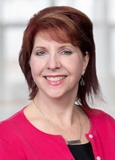
Oh, I wake up in the morning sun,
Another club to see, another day’s begun,
From Napa vines to Sonoma’s rolling hills,
To the Redwoods tall where Bigfoot chills.
I drive the coast, that ocean view,
District 5130, I'm proud of you!

From inland grapes to the foggy shore,
I’ve never loved the road this much before.
Each club I meet has that spark inside,
With laughter, passion, boundless pride.
Kristine Redko
District Governor 2025-26
Creative fundraisers light the way,
And projects grow stronger each day!

From helping hands across the sea,
To local youth with visions free,
We’re building peace, we’re doing good—
Together in our neighborhood.
I've now got friends from town to town,
Wearin’ Rotary blue and gold with crowns,
Of kindness, hope, and unity—
That’s the gift of Rotary!

~~~~~~~~~~~~~~~~~~~~~~~~~~~~~~~~~~~
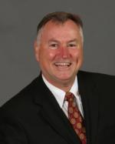
“Serving as Rotary District Governor was one of the most memorable and fulfilling experiences of my life. Traveling throughout the district, I was inspired by the passion and generosity of Rotarians who give so much of themselves to help others. The friendships formed, the lessons learned, and the moments of shared service not only made the year exciting and meaningful, but also deepened my appreciation for the true spirit of Rotary and how it can change lives—including my own.”
Jim O’Grady
District Governor 2024-25

~~~~~~~~~~~~~~~~~~~~~~~~~~~~~~~~~~~
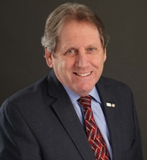

I had the privilege of serving as one of the 529 District Governors worldwide during my term. It was an even greater privilege to engage with every club and forge connections with more than 2,000 Rotarians in our District. I feel lucky that the vision I contributed still resonates and creates change. What vision would you like to bring forward? You could join the ranks of 529 visionary leaders
Tom Boylan
District Governor 2023-24

~~~~~~~~~~~~~~~~~~~~~~~~~~~~~~~~~~~
I must confess I wasn’t sure how this experience was going to work. As an active business owner I had no idea how I was going to juggle it all and still give the DG role the time and dedication that it deserved. But I quickly realized that, with the incredible support of Rotarians throughout our District, anything was possible. And not only possible – LIFE CHANGING – for ME. The magic of life is when we get whatever IT is out of our heads and INTO our hearts. My travels throughout the District, the people I met, the stories I heard, the new friendships that I made firmly solidified Rotary, and the power of it, in my HEART. And yes, it changed me forever.
Jennifer Strong
District Governor 2022-23

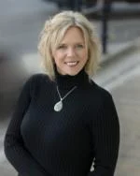

~~~~~~~~~~~~~~~~~~~~~~~~~~~~~~~~~~~

Why choose to be a District Governor?
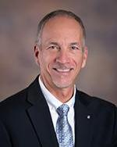
Being a district governor is an expansion of service, from the club to district level. While leaders explore this path for a variety of reasons, the outcomes are universal. Simply put, being a district governor expands your leadership skills, generates a deeper understanding of local and international efforts to improve communities and profoundly deepens your understanding of your personal leadership skills and how you choose to impact your community.
Michael Juric
District Governor 2012-2013

~~~~~~~~~~~~~~~~~~~~~~~~~~~~~~~~~~~

I have to say that my year DG was one of a super high, followed by one that was a super low…but only for a few days. And I’m talking about leading my year off with the Pedal 4 Polio 6 day350 mile bike ride from Crescent City to Petaluma. This has turned out to not be just the high of my DG year, but of my whole Rotary career. Raising a record amount of money ($140,000) the camaraderie that was developed, not only among riders and the SAG Crew, but the Rotarians along the way who fed us and put us up for the night. I will cherish that ride for the rest of my life. And then, the low that came when the Tubbs fire occurred, with literally thousand of homes lost, in addition to businesses, and unfortunately, one Rotarian even lost his grand children. But this low soon became a high with the whole district chipping in. We were fortunate in experiencing an unfortunate event that our Lake County Clubs had dealt with this kind of disaster before, and they soon got us organized and running in record time…even altering their 501c (3) which allowed us to immediately begin soliciting funds and helping out folks with stipends to small businesses to get them back up and running as soon as possible…Unfortunately something like 54 Rotarians lost their homes in the fire. They also lost their cherished Paul Harris Fellow paraphernalia in that fire. We were able to bring out the RI President that year, Ian Risely, to present new bling for those who lost theirs in the fires. We also earned the Trust of the Redwood Credit Union, who gave us $1 million to distribute to those in need, and when added to our other funds being donated, exceeded over $2 million dollars…because they trusted Rotary and all that it stands for. I was so fortunate to have such a fantastic talented eam in our District with literally everyone chipping in one way or another. So, these two events that happened, one by positive intention and one by happenstance will be with me the rest of my life…and that’s a good thing.
Bob Rogers
District Governor 2017-18

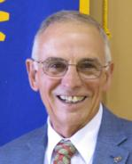

~~~~~~~~~~~~~~~~~~~~~~~~~~~~~~~~~~~
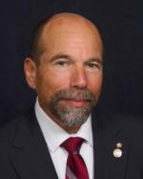

My best Rotary year ever. Meeting so many great Rotarians. Seeing and participating in so many amazing Rotary projects. Providing leadership to help make Rotary strong and projects happen. Receiving so much appreciation for what we do. Growing as a Rotarian and as a person.

Kevin Eisenberg
District Governor 2014-15

~~~~~~~~~~~~~~~~~~~~~~~~~~~~~~~~~~~
I loved being our District's 2002-2003 Governor! The most exciting and fun part was learning about all the amazing work our 43 (at the time) Clubs were doing. I attended their board meetings in conjunction with my official visits and was astonished at how casually some of them talked about their projects. I often had to say "wait, wait, say that again?!" because they took great things in stride like it wasn't that big a deal.
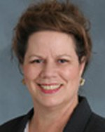
The other part that has been long lasting is the friendships I formed with my fellow DG's from around the world. Sadly, many have now passed on to the Rotary Club beyond. All these years later, I still correspond with some of them. We get to be a District Governor for a year but are a Past District Governor eternally.
Terri Clark
District Governor 2002-2003

~~~~~~~~~~~~~~~~~~~~~~~~~~~~~~~~~~~
My journey as Rotary District Governor – from apprehension to enlightenment.
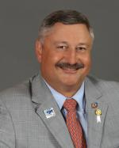
Once you realize the opportunities of service beyond the club, the role of district governor becomes intriguing. There is a normal apprehension because of the time commitment, but at the end of the day, you do have the prerogative to set your own schedule.
Once in the role, try not to set any limits; embrace every opportunity presented to you; seek them out. During the path of DGD, DGN, DGE and DG, I visited Africa, Mexico, British Columbia, and Hawaii. As DG, I participated in a 6-State, 14-City, 12-day Rotary Goodwill tour and also did a Rotary Friendship Exchange to D3060 in Gujarat, India. These life-changing experiences shall stay with me forever and further reinforce my life-long commitment to Rotary to Do Good in the World.
Wulff Reinhold
District Governor 2016-17

~~~~~~~~~~~~~~~~~~~~~~~~~~~~~~~~~~~
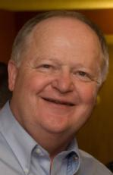
We just returned from a 9-day trip to Albuquerque where this year’s Zone Institute was held. I attended my reunion with 19 members of my 2010-11 class of Governors. Ever since we met in Portland, OR in 2008, we have managed to get together every year, except during Covid, for an annual reunion. Most of the time, it's at the Zone venue, but next year we are traveling to Ashland, OR for the Brit Festival in July. So, one of the perks of the position is the wonderful people, and relationships, you make as a District Governor. I'm not sure why my class has bonded so well, but with classmates like Johrita Solari, John Matthews and Steve Lewis, we live and breathe Rotary every day.
Jim Flamson
District Governor 2010-11

“I was early in my dental practice career. I had a 12 year old daughter. My wife ran the business element of the practice and would often be away with me for this. Those probably add up to a decision not to apply for this leadership position. But still I did. This decision literally changed my life: It taught me how to be a better leader, it associated me with some of the most incredible people, it brought so many memorable experiences for Patti and me, and it gave me an outlet to express my sense of what Rotary could do. It also helped my young daughter mature and it expanded my wife’s opportunities to her extreme satisfaction. Rotary brings opportunities and this position is loaded with those. I simply hope I gave as good as I got.”
John Blount
District Governor 1990-91

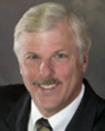

~~~~~~~~~~~~~~~~~~~~~~~~~~~~~~~~~~~
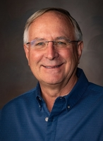

Many people have asked me that same question and I answer it by telling them where else would you have the opportunity to lead 1,800 local volunteers dedicated to local and international service in an organization with 1.2 million members worldwide. This is a journey that you share with a team of District 5130 leaders that support you during the lead up to your year as District Governor, during your year and as a Past District Governor. You receive comprehensive training and preparation from Rotary International and make life long friends in the process. It is one of the best choices you have to make an impact on issues that matter.
Jeff Kolin
District Governor 2026-27

~~~~~~~~~~~~~~~~~~~~~~~~~~~~~~~~~~~
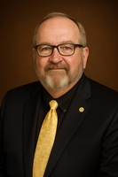

“When else would you get an opportunity to lead 2000 like-minded individuals who are committed to making the world a better place than as District Governor."
Jack Strange
District Governor 2027-28

